**`A**

**REPORT ON**

**Industrial Training at MENON PISTON LTD.**

Submitted by

**Ms. Kumbhar Pankaj Balasaheb**

Under the Valuable Guidance of

**Mr. S.S.Chavan**

(Designation- Assistant Professor)

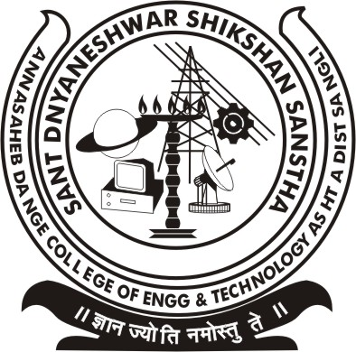

**DEPARTMENT OF MECHANICAL ENGINEERING**

**ANNASAHEB DANGE COLLEGE OF ENGINEERING AND TECHNOLOGY, ASHTA.**

***YEAR: 2016 – 2017***

**ABSTRACT**

In this vocational training report, we discuss all about the technical description which we got during training at Menon Piston Limited. Menon Piston manufacturing of auto components such as pistons, gudgeon pins and plungers.

In this report we discuss about various departments which are include in industry such as Machine shop, foundry and Heat treatment, Quality Assurance, Maintenance etc. Through this department we get in-depth knowledge of all processes which are performed for producing pistons, pins and plunger.

All departments gave important information of all processes. In addition with this the general information requires to producing a newspaper printing machine can be obtained through this vocational training.

Contents

1.1Company profile: 7

1.2 Company layout 8

**2. Departments in company** 9

2.1 Foundry 9

2.2 Heat treatment 10

2.2.1 Heat treatment on Piston 10

2.2.2 Heat treatment on Pin 11

2.3 Surface treatment 11

2.3.1 Tin plating Surface treatment 12

2.3.1 Anodizing Surface treatment 12

2.4 Machine shop 13

Fig 3. Machine shop. 13

2.4.1 Piston Machining 13

2.4.2 Pin Machining 14

2.5 Quality Assurance (QA) 16

**2.5.1 INSPECTION:-** 16

**2.5.1.1VISION INSPECTION:-** 16

**2.5.1.2 FUNCTIONAL INSPECTION**:- 16

**2.5.1.3 DIMENSIONAL INSPECTION**:- 16

**2.5.2 QUALITY PARAMETERS**:- 16

**2.5.3 MEASURING DEVICES:-** 16

2.6 MAINTENANCE 17

**2.6.1 Maintenance Department** 17

**2.6.2 Plant maintenance**:- 17

**2.6.3 Mechanical maintenance** 17

**2.6.4.** **Electrical & electronic maintenance**:- 17

**2.6.5 Additional Functions**:- 17

2.7 Store: 18

2.8 Packing and Dispatch: 18

. 19

**Table of figures**

Figure 1 Company profile…………………………………………………………………………………………………………………6 Figure 1 Foundry…………..…………………………………………………………………………………………………………………8 Figure 1 Machine shop..…………………………………………………………………………………………………………………12 Figure 1 Packing…………..…………………………………………………………………………………………………………….….17

**1. Introduction**

Menon Pistons Ltd. (MPL) ventured into the manufacture of pistons in 1971 without any collaboration of technical assistance of any piston manufacturer. Menon Piston manufacturing plant was set up at the industrial estate in shiroli, Kolhapur, a small industrial City, south east of Mumbai & delivered the First Ring carrier piston to the Indian diesel engine industry in 1971.

Menon Group, the Multi-product, high end critical auto components group with a turnover exceeding Rs.300 crore,& globally positioned with business activities spanning 24 countries around the globe exporting 35% of its production. The Menon Group’s historic commitment to Quality and customer service, strong corporate values, disciplined & professional management systems, emphasis on trust in business relations, & our ability to meet special needs is recognized the word over.

In the year 1985 a second unit was started in Sangli, yet again a small town 60km away from Kolhapur to manufacture a gudgeon pin & Pistons for stationary & industrial applications. In the year 1996 a third unit was added in Shiroli industrial estate exclusively for the manufacture of the small pistons to industrial applications &passenger’s cars. Currently this plant concentrates on the manufacturing of pistons for passenger car as an Exclusive &single source supplier to Maruti Suzuki Ltd. For their prize vehicle.

The company has kept pace with the growing trends by virtue of streamlining quality systems development of quality culture, adoption of latest technology equipment. Products of Menon Pistons enjoy a high degree of customer satisfaction &value for the money &has been the choice of discerning customers as most cost effective supplier.

Menon Piston Ltd. Manufactures aluminium alloy pistons, Piston pins & Piston rings for passenger cars, heavy and light commercial vehicles, heavy duty diesel engines for power generation and earth movers, compressors, etc.

## 1.1Company profile:

## 

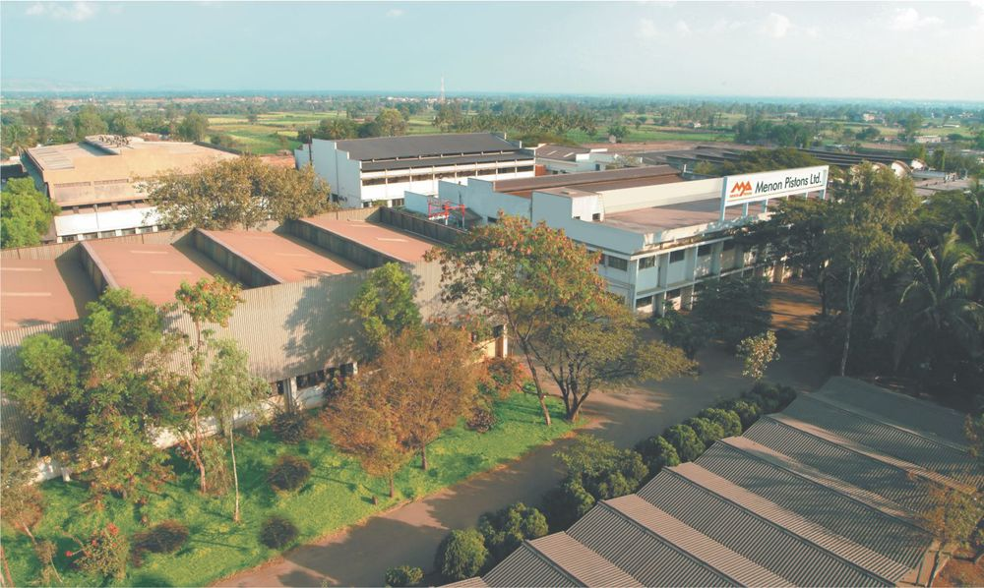

**Fig. 1 Menon piston**

* Name: MENON PISTONS LIMITED
* Corporate Office: MENON PISTONS LIMITED  
  Shiroli, Kolhapur-416 122, Phone : 0230 - 2468041/2468042, Email : [oad@menonpistons.com](mailto:oad@menonpistons.com)
* Plant-1 :  
  MENON PISTONS LIMITED  
  Shiroli, Kolhapur-416 122
* Plant-2 :  
  Menon Pistons Limited  
  H-1, MIDC, Kupwad Block, Sangli - 416436

## 1.2 Company layout

Maintenance

Heat Treatment Department

Piston Foundry

Temple

Administrative office

Vendor

Store

Centralised Coolant system

Parking

Security

Gate

Canteen

Garden

Tin plating & Anodising

Plunger Machining

Pin Machining

Piston Machining

# 2. Departments in company

2.1 Foundry

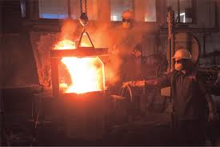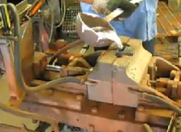

Fig 2 foundry.

A foundry is a factory that produces metal castings. Metals are cast into shapes by melting them into a liquid pouring the metal in a mold, and removing the mold material or casting after the metal has solidified as it cools. Quality begins at the source. The high quality of casting in our foundry using optimized online process controls ensures that piston blanks with desired alloy compositions & physical properties with optimum micro structures are manufactured.

Piston foundry process flow chart.

The foundry is the beginning of the piston. At the foundry the die is prepared by heating it to operating temperature for approximately one hour. This process allows the die to readily accept the molten material when it is poured. The material used is a 10% silicon content aluminium. The dies used are 5 piece and three piece. These dies are made from cast iron with steel inserts for the gudgeon pin holes and the cores. The cores dictate the placement of the gudgeon pin and can be located to give offset pins or square pins. The process starts by heating the material to 700 degrees Celsius. This is well above the melting point of the aluminium, but below its boiling point. The powder used to remove dust is Clenol-6 and Clenol-75. The material is then scooped up with a ladle from the crucible (the pot that holds the molten material). This is then poured into the die through the sprue. The centre die cavity Machine is to be used. The material is then allowed to cool before it is removed from the die and placed into a bin of hot water. This water is used to facilitate a more even settling of the hot metal. The hardnes should be around 90-125 BHN.   
After the castings have had time to cool they are placed into a heat treatment plant overnight. This process tempers the casting and ensures the piston will have improved qualities.   
After it is removed from the heat treatment the casting has its runner removed.   
This process takes little time and is fully automated.

2.2 Heat treatment

**Heat treating** is a group of [industrial](https://en.wikipedia.org/wiki/Industrial_process) and [metalworking processes](https://en.wikipedia.org/wiki/Metalworking) used to alter the [physical](https://en.wikipedia.org/wiki/Physical_property), and sometimes [chemical](https://en.wikipedia.org/wiki/Chemical_property), properties of a material. The most common application is [metallurgical](https://en.wikipedia.org/wiki/Metallurgy). Heat treatments are also used in the manufacture of many other materials, such as [glass](https://en.wikipedia.org/wiki/Glass). Heat treatment involves the use of heating or chilling, normally to extreme temperatures, to achieve a desired result such as hardening or softening of a material. Heat treatment techniques include [annealing](https://en.wikipedia.org/wiki/Annealing_(metallurgy)), [case hardening](https://en.wikipedia.org/wiki/Case_hardening), [precipitation strengthening](https://en.wikipedia.org/wiki/Precipitation_strengthening), [tempering](https://en.wikipedia.org/wiki/Tempering_(metallurgy)), normalizing and [quenching](https://en.wikipedia.org/wiki/Quench). It is noteworthy that while the term *heat treatment* applies only to processes where the heating and cooling are done for the specific purpose of altering properties intentionally, heating and cooling often occur incidentally during other manufacturing processes such as hot forming or weld

2.2.1 Heat treatment on Piston

In this study effect of heat-treatment on the mechanical properties of aluminium-based piston alloys has been investigated. AlCu4MgNi alloys and AlSiCuMgNi alloys with 10.5%, 12%, 18% and 24% Si were utilized for this purpose. After melting, alloys have been cast in the metal mould at 800 °C and solidified. During the heat treatment process pit type and box type furnace are used in heat treatment process of piston. The solution treatment has been performed at 500 °C for 5 h and then quenched. The samples have been aged at 180 °C for 9 h to observe the effect of aging on hardness properties.

2.2.2 Heat treatment on Pin

Each finished piston pin, after heat treatment, must show a minimum scleroscope hardness of the case of 70, a scleroscope hardness of the core of from 35 to 55 and a minimum crushing strength when supported as a beam and the load applied at the centre of 35,000lb. The heat treatment used to obtain the above physical properties consisted in carburizing at a temperature not to exceed 1,675 deg.F using methanol and acetone gas. For a sufficient length of time to secure a case of from 0.02 to0.04 in. deep. The pins are then allowed to cool slowly from the carbonizing heat, after which the hole is finish-machined and the pin cut to length. The finish heat treatment of the piston pin consisted in quenching in oil from a temperature of from 1,525 to1, 575 deg.F. To refine the grain of core properly and then quenching in oil at a temperature of from 1,340 to 1,380 deg.F. To refine and harden the grain of the case properly, as well as to secure proper hardness of core. After this quenching, all piston pins are tempered in oil at a temperature of from at 180̊C for 1-2 hours. A 100 percent inspection for scleroscope hardness of the case and the core was made, and no failures were ever recorded when the above material and heat treatment was used.

2.3 Surface treatment

Pistons with surface treatments & coatings, reduce friction & thereby improve fuel efficiency of environmentally friendly engines. Reduced scuffing makes cold engine start up more reliable and quicker. A skirt coated piston has better piston to cylinder 'SEAL' reducing the amount of combustion gases that can escape past the piston & leak into the crankcase. Thus, skirt coating reduces the amount of hydrocarbon emission that would normally pass into the environment as Air Pollutant.     
Our setup covers all the four types of surface treatment viz. 1.) Phosphate (Offers   better adherence for graphite coating helps in quicker running-in)   
2.) Graphite coating (Aids in initial lubrication),   
3.) Tin plating (Aids in initial running-in and protection)   
4.) Hard anodizing (Protection against thermal cracks)   
5.) Screen printing with Molybdenum Disulphide.

2.3.1 Tin plating Surface treatment

Transfer to STR-P

* Preparation of Tin plating bath
* Total volume180-200 liters.
* Heat water up to 65̊C & add 60gm/litre to70gm/litre sodium stannite powder.
* That is 12-14kg of sodium stannite powder.
* Change the tin plating bath on monthly basis.
* Tin plating temperature 80-95̊C.
* Preparation of Decreasing Solution
* Total Volume 125-150 liters.
* Make decreasing solution in prepare of 3-5% of metal cleaner.
* That is 5-6 kg of metal cleaner
* Change decreasing solution weekly.

2.3.1 Anodizing Surface treatment

Transfer to STR-P

* Preparation of Anodizing Solution
* Total Volume 480 liters.
* Add 15% sulphuric acid+ oxalic acid 5%+water 80%
* During the preparation process take care to avoid splashing of chemicals.
* Check density &concentration of the solutions at room temperature

2.4 Machine shop

Our CNC machine line-up includes turning centres for machining of re-entrant combustion cavities to ensure high accuracy of profile & machining centres for machining of pin hole relief / oval boring / trumpet boring (for enhancing fatigue life). We have deployed special machining facilities such as Camless CNC Oval Turning in order to achieve piston profile with desired tolerance & to machine symmetrical as well as asymmetrical profiles.

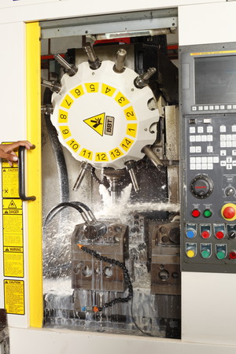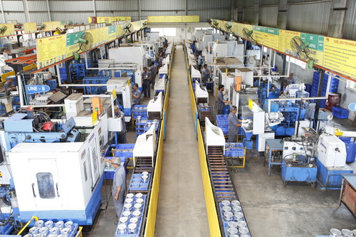

Fig 3. Machine shop.

2.4.1 Piston Machining

Transfer to piston M/C shop

All pistons manufactured are machined on dedicated CNC & special Purpose Machines, which delivery high accuracy, consistency and repeatability. Close tolerances are maintained throughout via automatic machining and Statistical Process Control. Full automation is instituted wherever it is consistent with improvements in cost and quality.

In Rough O.D. turning, there is turning of outer diameter using special purpose machine. IN open end Boring & facing there is boring of holes & facing of piston using SPM. In semi finish boring there is semi finish of holes. In oil hole drilling, holes are drilled for lubrication of oil.In rough & finish dishing, there is dishing of piston done on the top side of piston.in form turning ,cam & profile tuning is done of piston .In debarring, there is neaten and smooth the rough edges or ridges. In circliping, A **circliping**  also known as a **C-Clip**, **Seeger ring**, **snap ring** or **Jesus clip**, is a type of [fastener](https://en.wikipedia.org/wiki/Fastener) or ring consisting of a semi-flexible metal ring with open ends which can be snapped into place, into a [machined](https://en.wikipedia.org/wiki/Machining) [groove](https://en.wikipedia.org/wiki/Groove_(machining)) on a dowel pin or other part to permit [rotation](https://en.wikipedia.org/wiki/Rotation) but to prevent lateral movement. After that there is cleaning of piston. After that there, there is pocket milling of piston if required. At last, there is punching, plating, O.D. checking & packing..

2.4.2 Pin Machining

In this after the material is received. The rod is cut into pieces using SPM at speed 250rpm and at time more than 30 seconds. Then there is drilling on first & second side of work piece using horizontal drilling machine. Then there is boring of drilled holes. After that there is Ball pressing to finish the bored holes. At last there is facing of pin. After that is sent to heat treatment. In this honning machine is used for bore finishing of airplane pins is used.

After that following machining process are done as follows:

1. Grinder 1 :( leadcoping machine to be used)  
   Nearly 200µm material is removed
2. Grinder 2 :( leadcoping) cross section nearly (+60 µm remains).
3. Radius & Chamfering:  
   0.4µm to 0.6µm
4. Surface grinding:  
   exact size
5. Super finish:  
   seven finishing tools made the surface of pins mirror finish.
6. Crack detection(NDT)

Magnetic particle testing for material crack, heat treatment crack, grinding crack.

1. Inspection.

2.4.3. Plunger Machining

In machining process starting processes are to be performed are to be given to contractors. The operations to be given to done by the contractors are from bar approval to S.F. & Heat treatment of plunger. Remaining operations are to be done in machining shop, the operations to be done in machining shop are as follows:

1. Cylindrical grinding

This operation is to be performed on cylindrical grinding machine.

1. Facing
2. Circliping
3. Threading
4. Parting

The all above operations are to be done on one cnc machine.

After that there is inspection. At last there is Packing & Dispatch of plunger.

## 2.5 Quality Assurance (QA)

### **2.5.1 INSPECTION:-**

The process of checking quality of a product can be termed as inspection. Mainly there are three types of inspection. They are,

### **2.5.1.1VISION INSPECTION:-**

The inspection which can be carried out according to shape is termed as vision inspection. In this type of inspection only shape of a component is observed.

### **2.5.1.2 FUNCTIONAL INSPECTION**:-

The inspection which is based on different processes such as chemical processes, NDT, Laser beam, etc., is termed as functional inspection.

### **2.5.1.3 DIMENSIONAL INSPECTION**:-

The inspection which is depending on the measurement of dimensions is termed as dimensional inspection. In this type of inspection the measurement of every part can be done.

### **2.5.2 QUALITY PARAMETERS**:-

1. Green Tag: - Acceptance.
2. Red Tag: - Rejection.
3. Yellow Tag: - Rework.

### **2.5.3 MEASURING DEVICES:-**

### **1. CMM:-**

CMM stands for Co-ordinate Measuring Machine. It is a 3 D that is three dimensional machines through which dimensions can be measured in three directions, X, Y and Z. Least count of a CMM is 7 micron. Up to 0.04 mm accuracy can be obtain with this measuring device. CMM is used to check bore size, degrees and all dimensions.

### **2. Plug Gauges**:-

Plug gauges mainly include GO and NOGO gauges. They are widely used for checking internal holes. Instead of color code sticker code is used for both GO and NOGO gauges.

### **3. Snap gauges**:-

Snap gauges are widely used for checking external dimensions.

## 2.6 MAINTENANCE

### **2.6.1 Maintenance Department**

### **Maintenance department is established to keep machines in working conditions at any instant. Maintenance of all productive elements present here is done by this department. Maintenance can be broadly classified as follows,**

1. Plant maintenance
2. Mechanical maintenance.
3. Electrical & electronic maintenance

### **2.6.2 Plant maintenance**:-

Maintenance of all constructions is under plant maintenance. Maintenance of all m/c foundations, roofing, drainage system, compounds etc. is done under this kind of maintenance. Construction of new building is also done by the department. It majorly involves civil Engg. Work. To do all these things dept. use external agency as no construction authority are with the department.

### **2.6.3 Mechanical maintenance**

### **Damages to construction of machines, assemblies, drives etc. is done under mechanical maintenance. Maintenance of cranes, load carrying vehicles is also done under mechanical maintenance. For mechanical maintenance an Engg. Assistance Engg. Fitters & welders are with the dept.**

### **2.6.4.** **Electrical & electronic maintenance**:-

Maintenance of driving motors; electrical mains, lights, power supply etc. are done as electrical maintenance. Electronic maintenance is regarding electronic faults of CNCs VMCs & other numerically controlled machines.

### **2.6.5 Additional Functions**:-

1. Installation & commissioning of new m/c if brought.
2. Shifting of machines if necessary.
3. Appointing agencies for plant maintenance works.
4. Keeping operating manuals & other documents of machines.
5. Keeping record of maintenance history.

## 2.7 Store:

It is a one of the important and large department. All the accessories relate to manufacturing can be stored in main store department. This department includes small parts such as raw material, packed material, tools etc. During manufacturing any machine sometimes products get damaged after assembly of machine. Such types of dispatched pro are stored in dispatch store department. From this department then raw material is sends to related department. From this packed components such as Piston, plunger, pin are send to the different companies according to their requirement.

## 2.8 Packing and Dispatch:

This if final stage, after the inspection is done the packing is done. In this Packing of piston Plunger, pin is done. According to the customers or companies requirement no. of quantities are packed in box and sent to the customers. And label containing the information about the no of quantities, type are labeled on piston. Finally, it is dispatched.

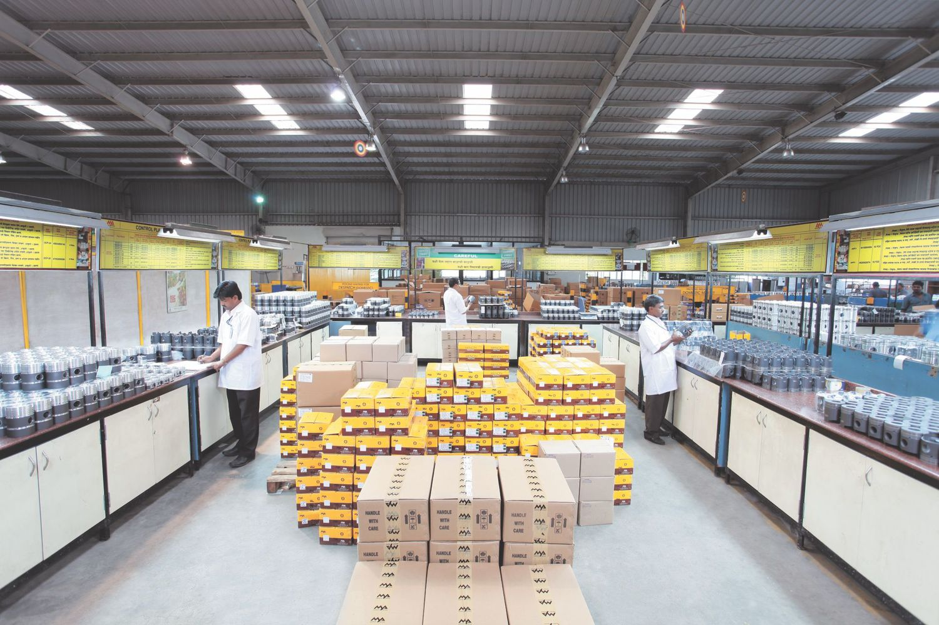

**Fig. 4 Packing**

CONCLUSION

Menon Piston Ltd., India is a challenging place for students to do their training program. By this training program, we have gained a wide knowledge of secretarial job scope and also the technical works from our superiors.

The industry provides us depth knowledge of different processes. Not only learning the general work scope here but the practical students also have got the opportunities to implement the work scope with their own strength and abilities during the internship. It was an advantage for us to be in the all different division where we have boosted up our skills and abilities. The conclusion, we can make that Menon Piston Ltd., is a well suited industry for students performing their vocational training.

.